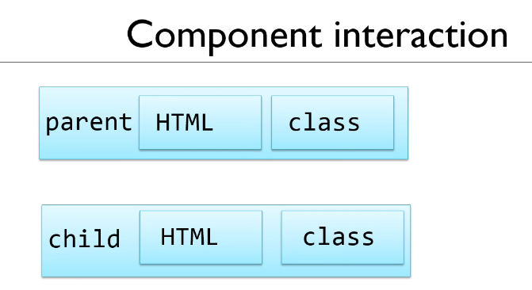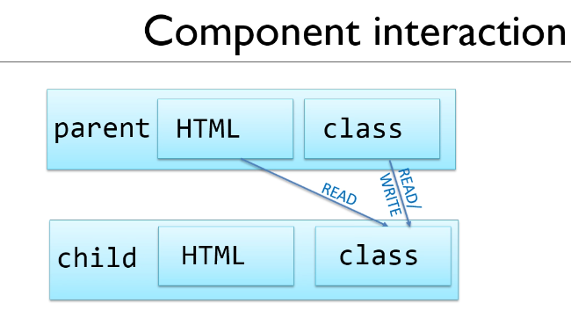

Working in the Footer.component.ts class file

Add the variable lastAccessed = “”;

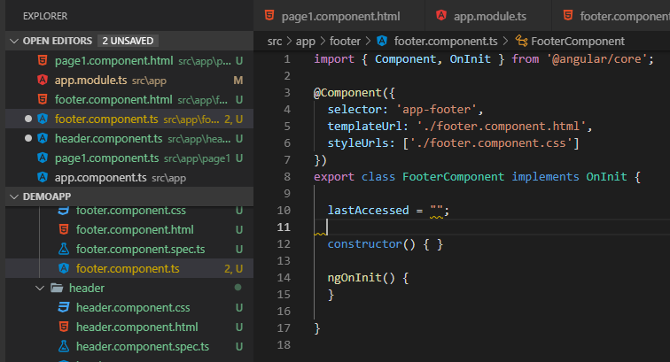

Now in the HTML component:

Bind the variable lastAccessed to the footer.component.html with the {{ lastAccessed }}

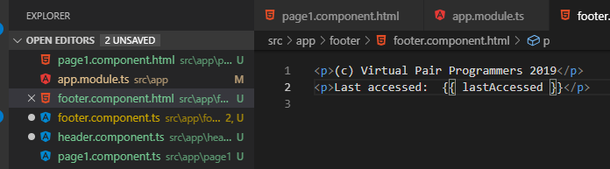

Check if the page is updated:

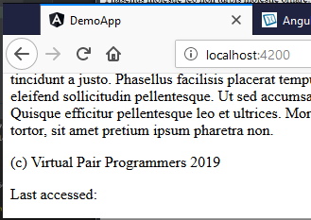

Put a button on the Parent component and populate the Child component:

Parent Component is the app.component.html

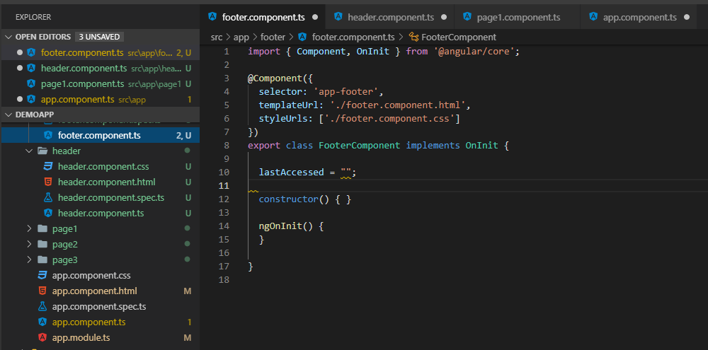

Child Component is the footer.component.html

Add the click event to the footer button test the button click:

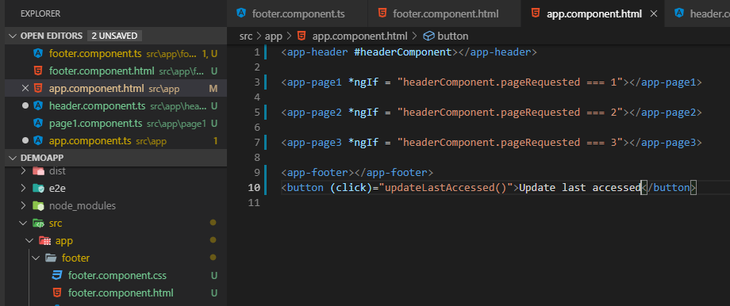

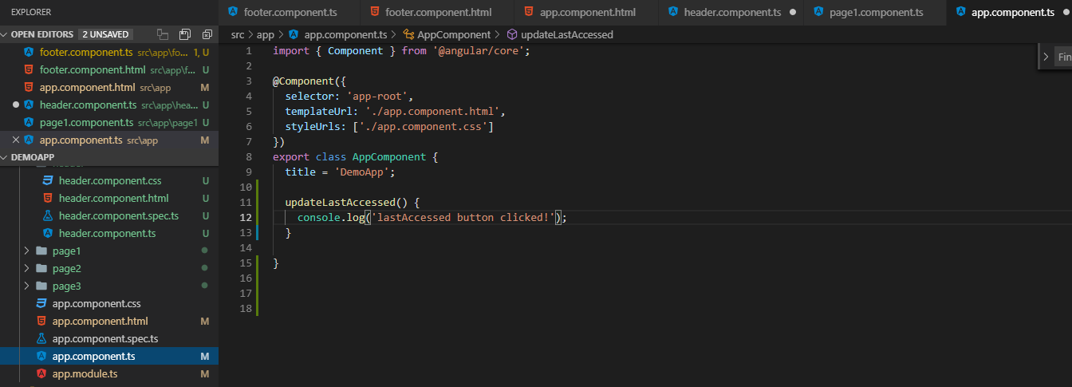

Now test the button Click

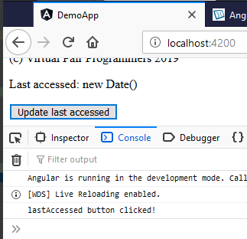

Object name: footerConponent: FooterComponent:

Object of type FooterComponent

Now, the current object “this” is the app.component has access to the FooterComponent.

this.footercomponent.lastAccessed = new Date().toString();

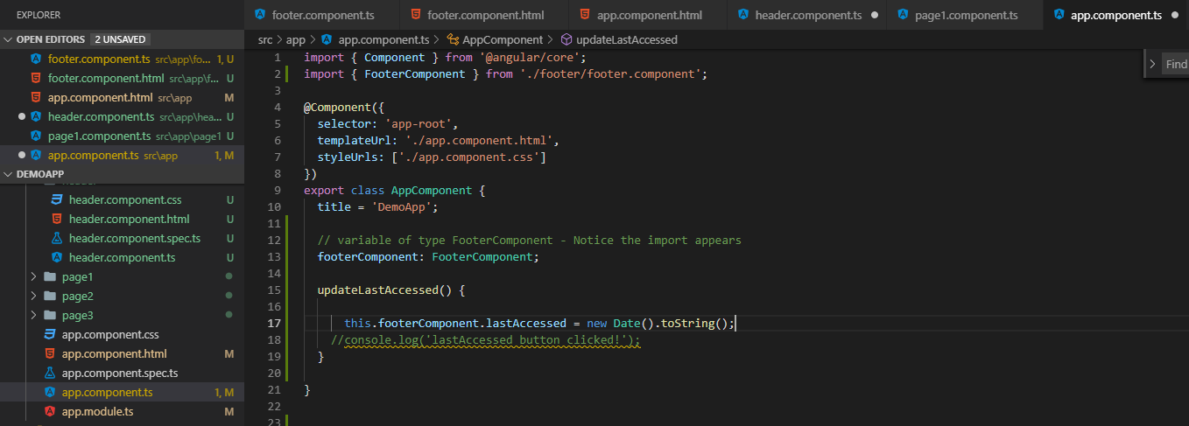

Template reference #footer

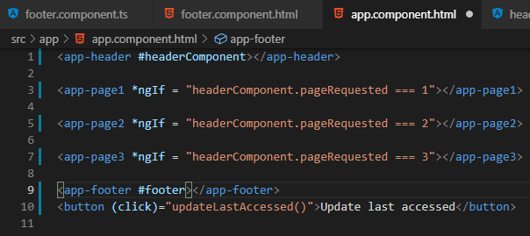

@ViewChild(‘footer’: {static: true}) connects the Parent to the Child

Make sure every page is saved CTRL+S

Test the button:

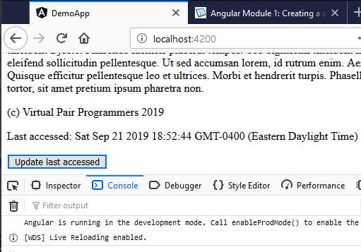

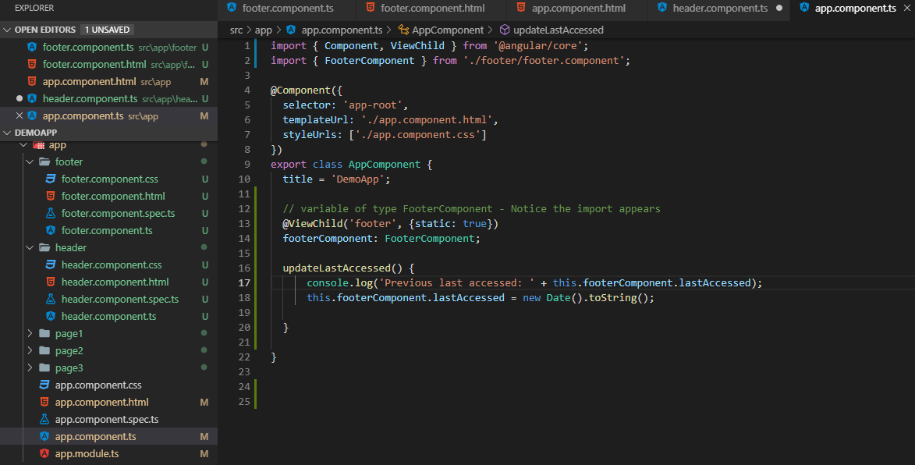

Test the last accessed Console.log()

Now you see that you can READ and WRITE from the Parent to the Child

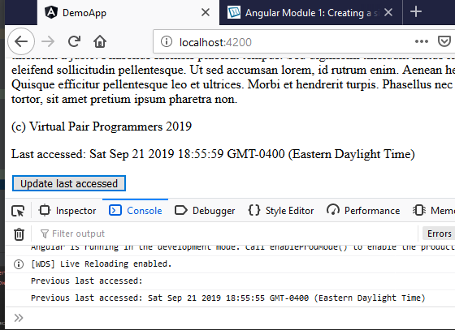

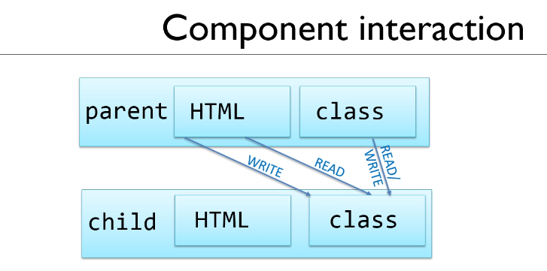

Use startTime as the string variable in the app.component

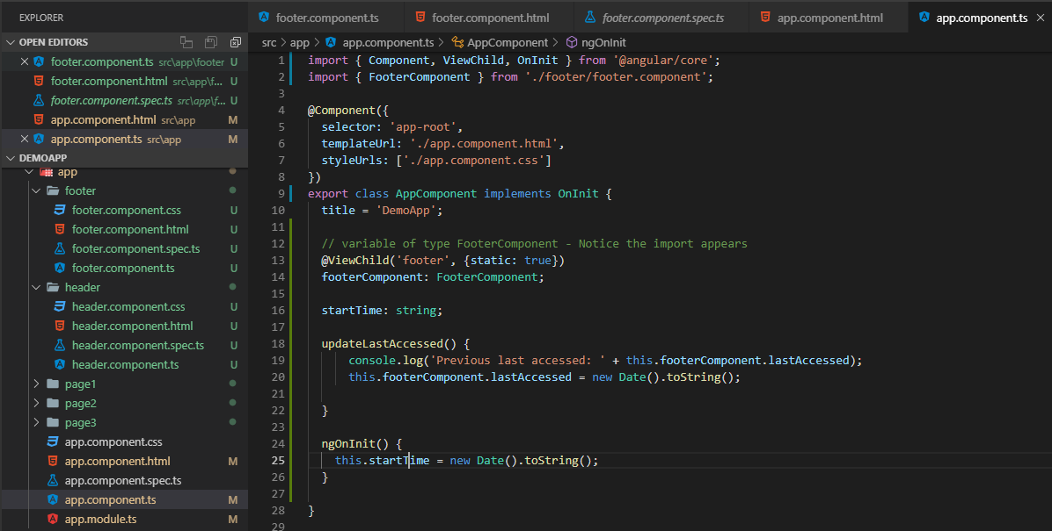

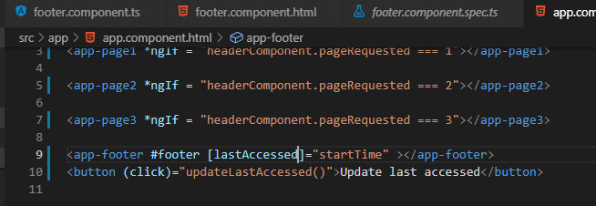

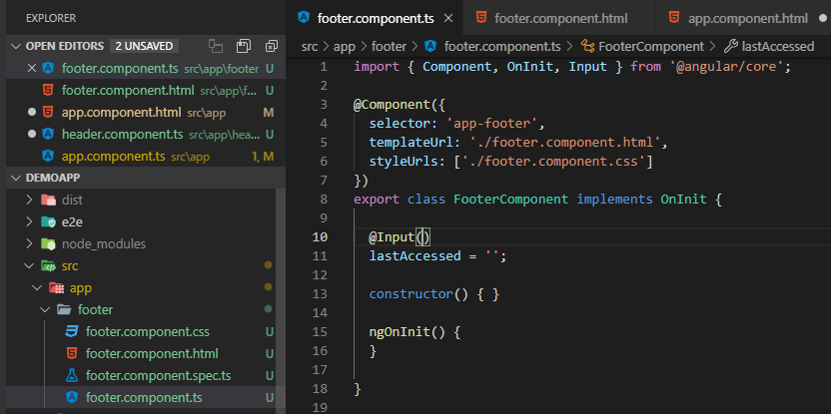

Now the binding code compiles:

Test it:

